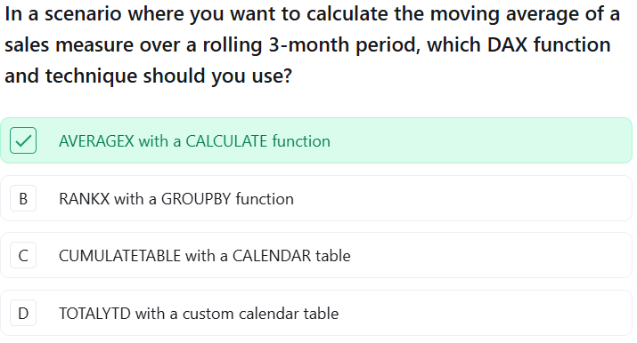

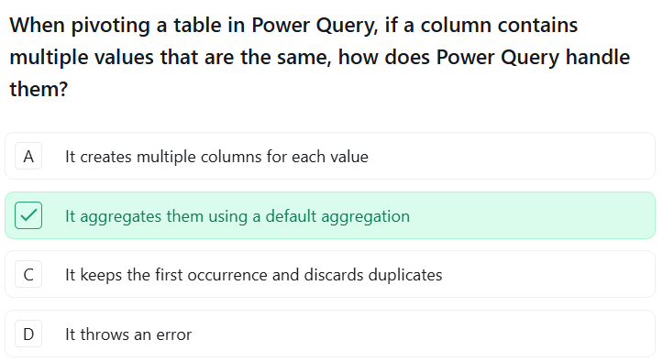

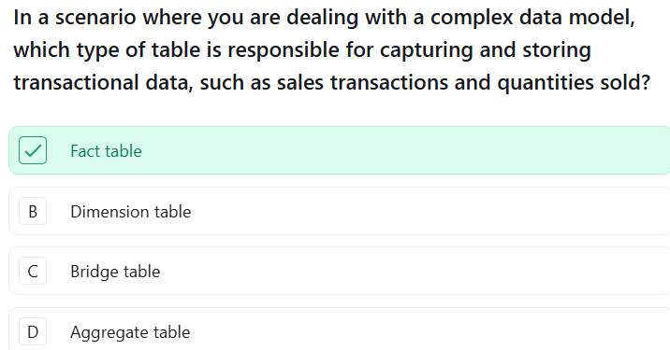

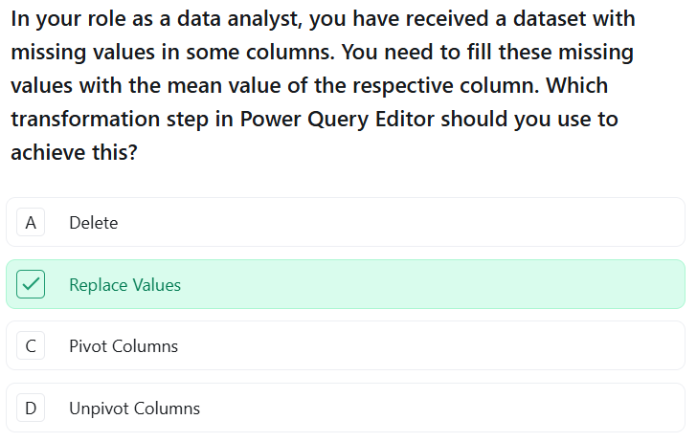

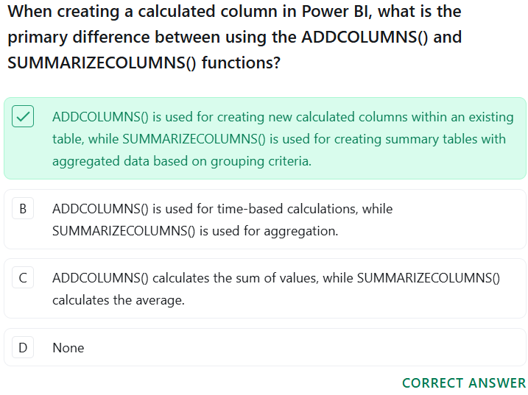

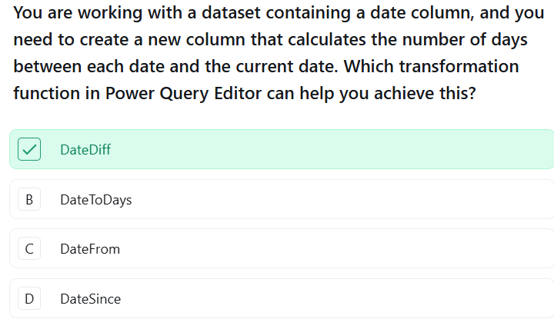

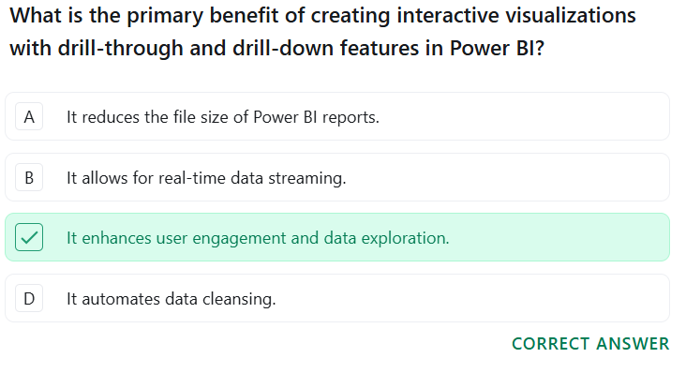

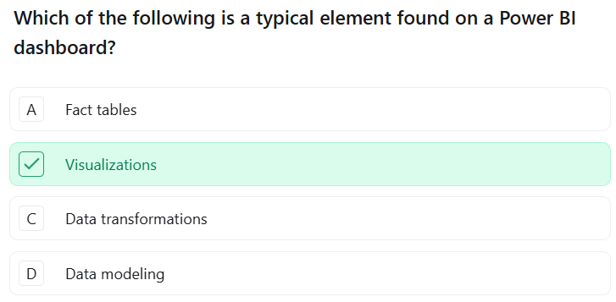

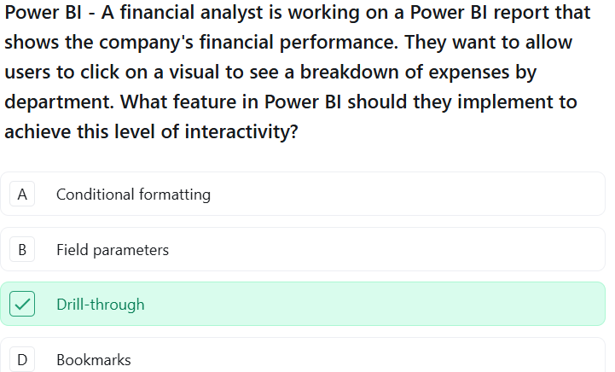

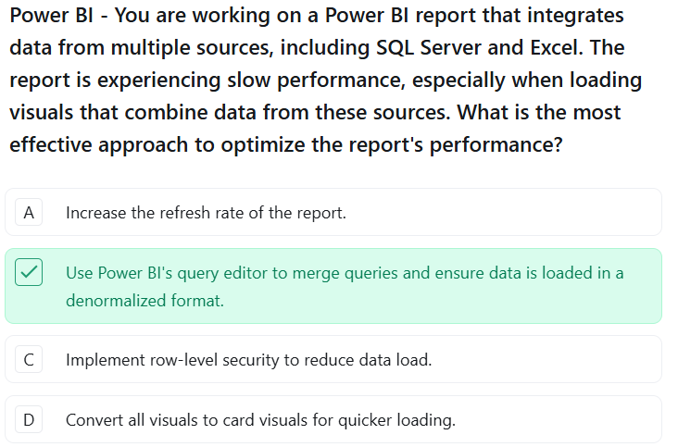

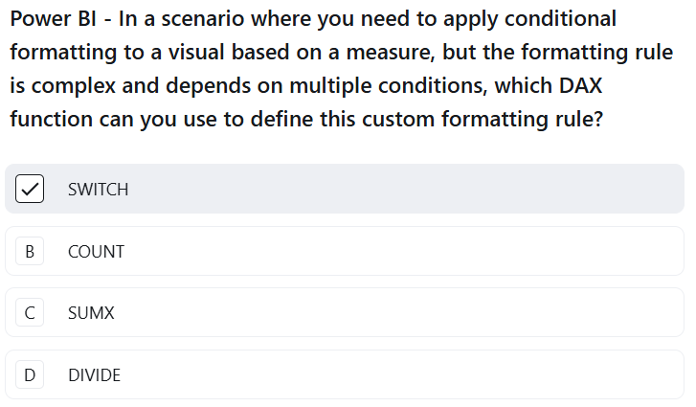
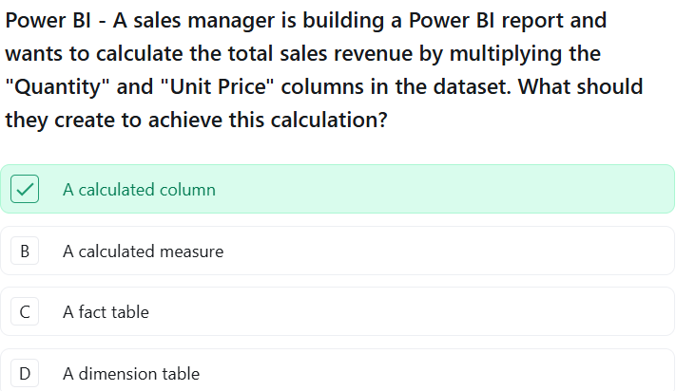

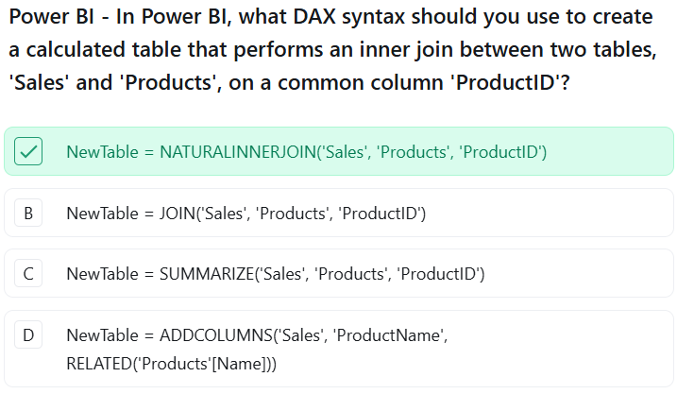

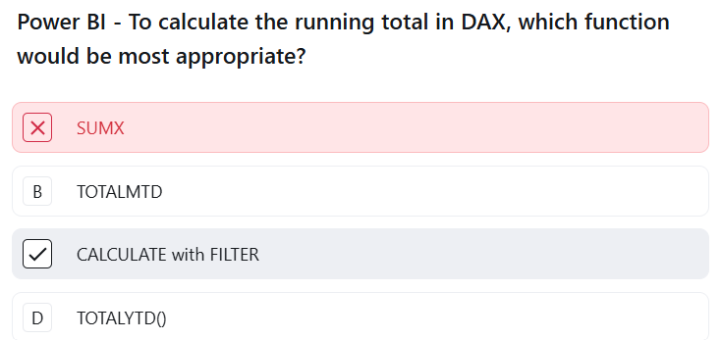

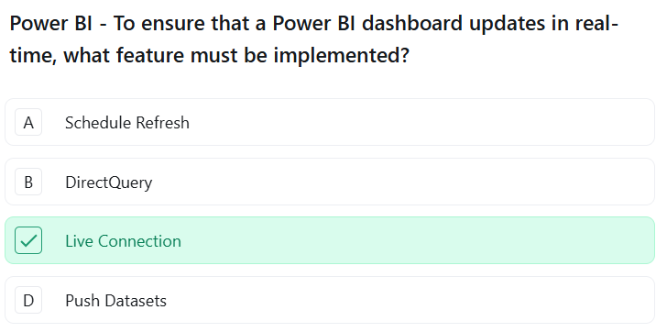

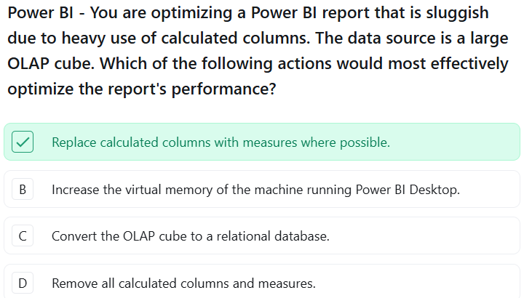

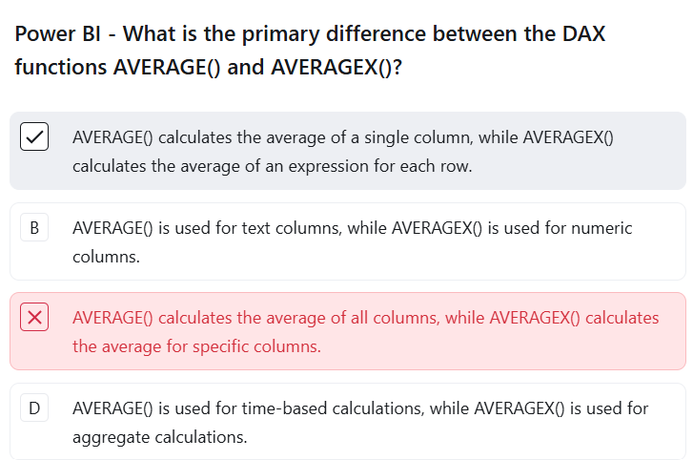

A column called Amount contains the following values:
100, 250, 450, "N/A", 600, "Missing"
You change the column's data type to Decimal Number, resulting in errors for the text values.
You want to replace invalid values with 0 while retaining all valid numeric values.
Which approach is most appropriate?
A. Remove the entire Amount column.
B. Remove rows containing errors.
C. Replace Errors in the Amount column with 0.
D. Replace all text values in the entire query with 0 before changing the data type.
You have a SalesFact table and a CustomerDim table.
CustomerDim contains:
- CustomerID
- CustomerName
- City
- State
- Segment
- DateOfBirth
The business wants to analyze sales by State, City, and Customer Segment.
Where should these attributes generally reside?
A. SalesFact
B. CustomerDim
C. A separate measure table
D. The Date dimension
Correct Answer: B

Q5. Star Schema Design
You are designing a Power BI model for an e-commerce company. You have:
- SalesFact
- CustomerDim
- ProductDim
- DateDim
- StoreDim
The SalesFact table contains foreign keys and measures such as Quantity, SalesAmount, DiscountAmount, and CostAmount.
Which model design is generally most appropriate?
A. Connect CustomerDim directly to ProductDim and ProductDim directly to DateDim, with SalesFact at the end of the chain.
B. Connect all dimension tables directly to SalesFact using one-to-many relationships, with dimensions on the "one" side.
C. Connect all dimension tables directly to each other to reduce the number of relationships.
D. Create many-to-many relationships between all dimensions and SalesFact.

Q1. Drill Down Hierarchy
A column chart contains a hierarchy:
Year → Quarter → Month → Day
The visual is currently displaying sales by Year. The user clicks the Drill Down button and selects the year 2026.
What will Power BI display?
A. Sales for all years broken down by quarter
B. Sales for 2026 broken down by quarter
C. Sales for 2026 broken down by month
D. Sales for all years broken down by month

Q2. What Can Field Parameters Change?
A field parameter is used in a visual's Axis. The parameter contains:
- Product
- Category
- Region
What happens when the user selects Region from the parameter slicer?
A. The visual is replaced with a new visual showing Region.
B. The Axis field used by the visual changes to Region.
C. The entire dataset is filtered to only include Region.
D. A new calculated column called Region is created.

Q2. What Does a Bookmark Save?
A Power BI developer creates a bookmark while a report page has a specific combination of filters, slicer selections, and visual visibility.
What can the bookmark capture?
A. Only the formatting of the visuals
B. Only the current page
C. The current state of the report, including relevant filters, slicer selections, and visual visibility
D. The underlying Power Query transformations
A Power BI developer has the following requirements:
1. Save the current state of a report page, including selected filters and slicers.
2. Allow users to navigate from a selected customer to a detailed customer page.
3. Allow users to switch between Product, Category, and Region in the same visual.
4. Allow users to move from Year → Quarter → Month within a visual.
Which option correctly matches the requirements with the appropriate Power BI concepts?
Option | 1 | 2 | 3 | 4
A. | Bookmark | Drillthrough | Field Parameter | Drill Down
B. | Drillthrough | Bookmark | Drill Down | Field Parameter
C. | Field Parameter | Drill Down | Bookmark | Drillthrough
D. | Bookmark | Field Parameter | Drillthrough | Drill Down

Q1. Identify the Correct Power BI Concept
Consider the following requirements:
1. Organize data into separate fact and dimension tables for an efficient analytical model.
2. Define how rows in a Customer table are associated with rows in a Sales table.
3. Calculate Total Sales dynamically based on the current filter context.
4. Create a new value for every row in a table based on an expression.
Which option correctly matches the requirements?
Option | 1 | 2 | 3 | 4
A. | Relationship | Schema | Calculated Column | Measure
B. | Schema | Relationship | Measure | Calculated Column
C. | Schema | Measure | Relationship | Calculated Column
D. | Relationship | Calculated Column | Measure | Schema

Q4. Identify the Correct Connection Type
A company wants to:
1. Maintain an independent Power BI model containing a copy of the source data.
2. Avoid loading the complete source dataset into Power BI because the source is very large.
3. Use an existing Analysis Services model as the source for the report.
Which option is correct?
Option | 1 | 2 | 3
A. | Live Connection | Import | DirectQuery
B. | Import | DirectQuery | Live Connection
C. | DirectQuery | Live Connection | Import
D. | Import | Live Connection | DirectQuery
You have already created these measures:
Total Sales = SUM(Sales[SalesAmount])

Total Profit = SUM(Sales[Profit])
You now need to calculate Profit Margin % = Total Profit / Total Sales.
Which DAX formula is the most appropriate?
A. Profit Margin % = DIVIDE([Total Profit], [Total Sales])
B. Profit Margin % = [Total Profit] / 100 * [Total Sales]
C. Profit Margin % = DIVIDE([Total Sales], [Total Profit])
D. Profit Margin % = SUM([Total Profit]) / SUM([Total Sales])
The Sales table contains multiple rows for each OrderID. You need to calculate the average sales value per order, where sales for each order are first aggregated.
Which DAX formula is most appropriate?
A. Average Order Value = AVERAGE(Sales[SalesAmount])
B. Average Order Value = AVERAGEX(VALUES(Sales[OrderID]), [Total Sales])
C. Average Order Value = AVERAGEX(Sales, Sales[SalesAmount])
D. Average Order Value = SUM(Sales[SalesAmount]) / COUNT(Sales[OrderID])
You have a proper Date table and a measure [Total Sales]. You need to calculate sales for the corresponding period in the previous year.
Which DAX formula is correct?
A. Previous Year Sales = CALCULATE([Total Sales], DATEADD('Date'[Date], 1, YEAR))
B. Previous Year Sales = CALCULATE([Total Sales], DATEADD('Date'[Date], -1, YEAR))
C. Previous Year Sales = CALCULATE([Total Sales], DATEADD('Date'[Date], -1, MONTH))
D. Previous Year Sales = CALCULATE([Total Sales], YEAR('Date'[Date]) - 1)
A report contains a bar chart showing sales by region and a pie chart showing sales by product category. When a user selects a region in the bar chart, the developer wants the pie chart to respond to that selection.
Which Power BI feature controls this behavior?
A. Edit Interactions
B. Drillthrough
C. Bookmarks
D. Field Parameters
You want to perform calculations such as:
- Year-to-Date Sales
- Previous Year Sales
- Month-to-Date Sales
What is generally required for reliable time-intelligence analysis?
A. A dedicated Date table containing a continuous sequence of dates
B. A calculated column containing only the year
C. A text column containing month names
D. A separate table containing only financial years
Which of the following best describes Microsoft Power BI?
A. A database management system used primarily to store and manage transactional data.
B. A business intelligence and data visualization platform used to connect, transform, model, analyze, and visualize data.
C. A programming language used to develop enterprise applications and websites.
D. A spreadsheet application primarily used for creating and maintaining tabular data.
Which of the following correctly lists the major components of Power BI?
A. Power BI Desktop, Power BI Service, Power BI Mobile
B. Power Query, Power Pivot, Power View
C. Power BI Desktop, Excel, SQL Server
D. Power BI Service, Power Automate, Power Apps

